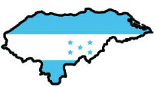
Boxes for Honduras

Mission Project 2013
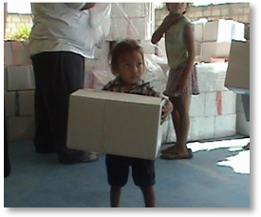
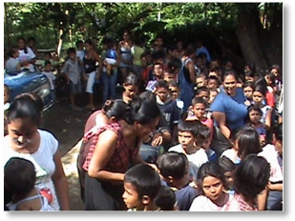
Looking for a Mission project for your school, organization or church?
Join Gathering Hearts for Honduras, missionaries Gary and Cheryl Kuney and participating support groups in sending gift boxes around Christmas time to the children of San Pedro Sula, Honduras and the surrounding jungle areas.
Each child from infant-14 yr. receives their own Christmas box. Beacon Hill Baptist, the distribution center for the gift boxes, collects items all year and then assembles over 1000 boxes in early fall.
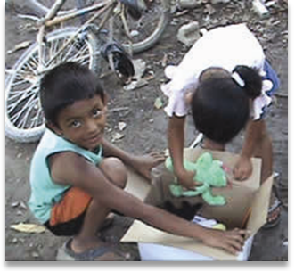
You can be involved in this exciting project by either collecting items or donating money to buy needed supplies.
Here is a sampling of what goes in the boxes.
- Evangelistic coloring book tract, written in Spanish-Would you write one?
- Crayons, Pencils, Spiral Notebooks, Cheese/Peanut Butter Crackers, animal cookies, Cheezits, non candy items.
- Stuffed animals, small age appropriate toys: i.e., matchbox cars, small dolls, small hand-held games, figures, jump ropes, balls, small Frisbees, yo-yos, etc. (no war or monster-type toys)
- Personal Hygiene items: i.e., toothbrush, toothpaste, soap, wash cloth
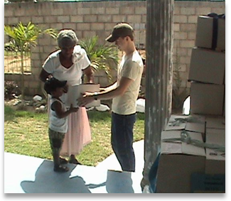
- Clothing items: Summer things only, shoes, hats, socks, undies
- For infants: Diapers (cloth with pins or disposable), small diaper bags, blankets, bottles, sippy cups, pacifiers, rattles, formula,etc.
Want more information? Please write for a more extensive supply list of items and instructions on becoming involved.
No group is too little or big to get involve. It’s fun!
Candy Matheny Malachi2_16@hotmail.com 918-627-6436

